**Breadfruit With Smoked Pigtails Simmered In Coconut Milk.**

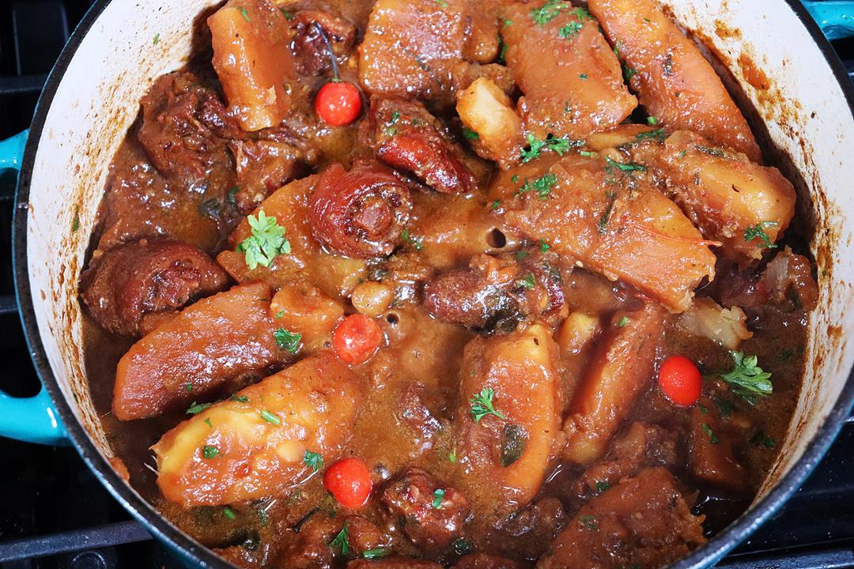

**INGREDIENTS**

2 lbs smoked (salted) pigtails (cut 1 inch pieces)  
1 lime (juice)  
1 large breadfruit (cut into wedges)  
1 scotch bonnet pepper (sliced)  
1 heaping tablespoon Caribbean Green Seasoning  
1 tablespoon Worcestershire sauce  
1/2 teaspoon black pepper  
2 tablespoon olive oil  
1 1/2 tablespoon golden brown sugar  
1 1/2 cup coconut milk  
2-3 cups water  
1 tomato (diced)  
3 slices ginger  
1/2 large onion (sliced)  
4-6 cloves garlic (smashed)  
2 scallions (chopped)  
2 pimento peppers (aka seasoning peppers)  
1/2 teaspoon salt (adjust)  
3 wiri wiri peppers  
2 tablespoon chopped parsley

**METHOD**

1. Cut the smoked (salted) pigtails into 1 inch pieces, then place in a bowl with water and add the lime juice. Let it soak for about 1 hour.
2. Lets prep the breadfruit. Cut off the stem (giving you a flat surface to work with), then cut into wedges, remove the core (discard) and then the skin. Wash with cool water.
3. Season the pigtail pieces. Drain and rinse with cool water. Now add the Caribbean Green Seasoning, Worcestershire sauce and black pepper. Mix well. Allow to marinate for about 30 minutes (maybe you can do this and then get to preparing the breadfruit).
4. Heat the olive oil (use any oil you like cooking with) on a high heat in a deep, heavy pot. Add the brown sugar  and stir (with a dry spoon). The sugar will melt, go frothy, then amber in colour. This is when you’ll add the seasoned pigtail pieces to the pot. **Should the sugar GO BLACK … STOP**! Allow the pot to **cool completely**, wash and start back. Or it will be bitter tasting.
5. Stir well to coat the pieces of pig tails. Lower the heat to medium and cook for about 4-5 minutes. Then add the breadfruit pieces and stir well to coat those as well. Now add the coconut milk and stir to loosen up the bits on the bottom of the pot.
6. Top with everything else but the parsley and bring to a boil.
7. **Note!** Do not break the Wiri Wiri peppers (if you have them) or they will release the raw heat. Remember you can remove the seeds off the Scotch Bonnet to control some of it’s heat. Or leave **both out** if heat is not your thing. Add a pinch of curry powder for a lovely addition of flavor.
8. op with the chopped parsley and enjoy. At the end you can personalize this by adjusting the salt and the consistency of the gravy. Remember it will thicken as it cools. All of this is explained in the video below.